SUNKARA SOMESWARI

9550549055

[sunkarasomeswari2003109@gmail.com](mailto:sunkarasomeswari2003109@gmail.com)

20/07/23

**Punith Sir Assignment**

Today’s assignment topic is Data types are converting with each other and prove what type of Type Casting is that. Proving of conversion of data types in Type Casting is in table format and also examples of each and every conversion of data types.

Before we going with this above topic, we want to know what is type casting and data types.

**What** **is Type Casting?**

Theway of converting data from one data type to another data type is called Type Casting. By using casting data cannot be changed but only the data type is changed. There are two types of Type Casting’s.

1. Implicit type casting.

2. Explicit type casting.

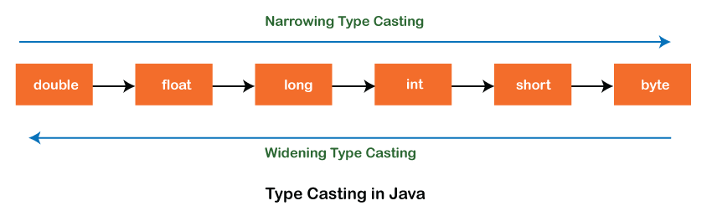

1. **Implicit type casting(automatic type conversion):**

The conversion of smaller data type to the larger datatype is called implicit type casting or widening.

The compiler will automatically change one type of data into another if it makes sense. For example if you assign a integer value to the float variable the compiler will automatically convert the int to a float.

1. **Explicit Type Casting:**

Conversion of larger data type into a smaller datatype is called Explicit Type Casting or Narrowing.

In explicit type casting there is a possible chance of losing the data.

It does not happen on its own. We must do it explicitly otherwise compile-time error is thrown.

**Data types**

There are two types of data types

1. **Primitive data types**: the primitive data types include Boolean, char, byte, short, int, long, float, double.
2. **Non primitive data types:** the non-primitive data types include classes, interfaces, and arrays.

I know little bit about the above topics now it’s time to going to solve today’s assignment, let’s go. Convert each datatype of data and know that will be implicit typecasting or explicit typecasting.

1. **CHAR**

char is used for character data type of data in real world issues, it can be stored 2bytes of data. Representation of char is in single cotes(‘’).

**Ex:1 :**Converting char data type to char data type of data

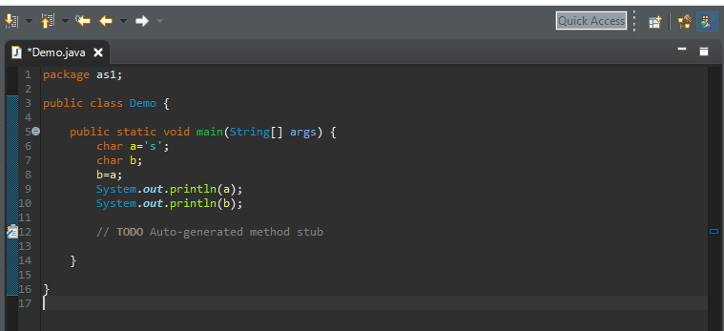

Output: converting of char data type with char data type of data will be not required but it may be implicit data type.

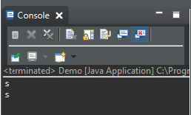

**Ex 2:** checking Type casting of char data type with byte data type of data

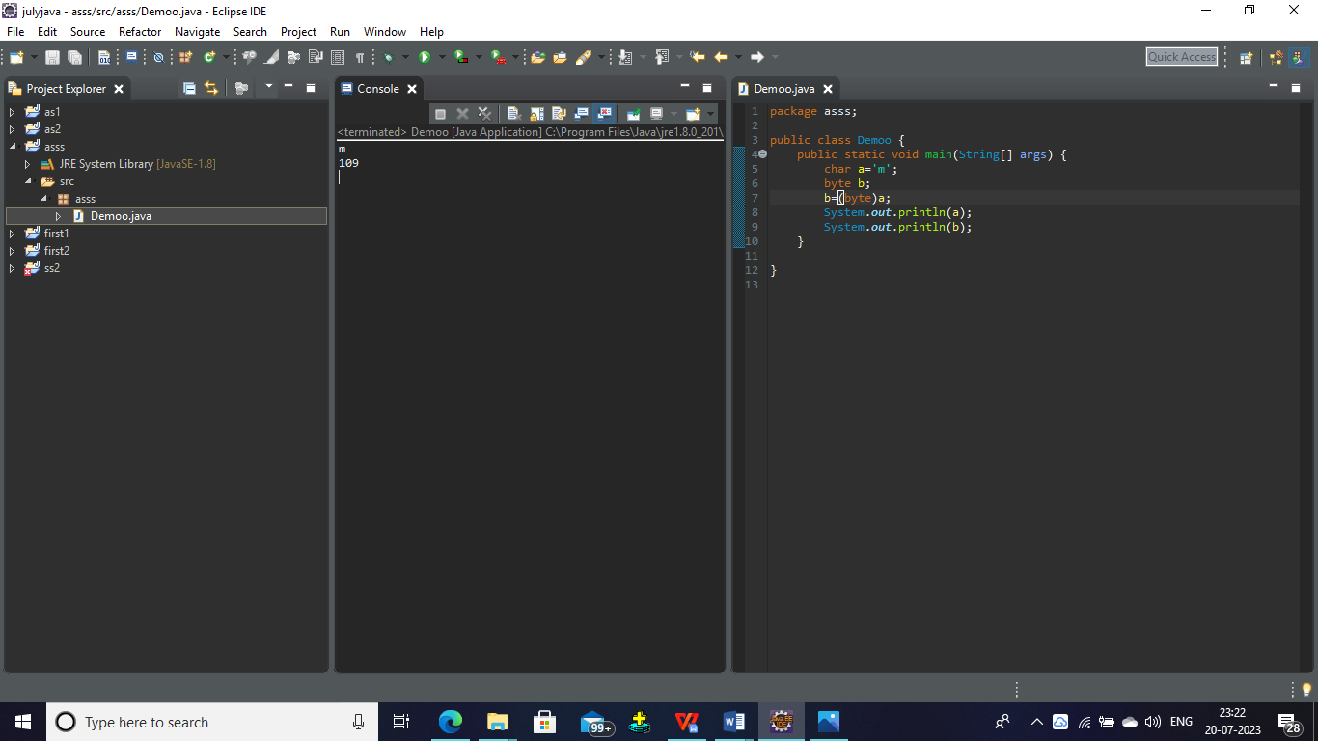

**Conclusion** : it shows an error for conversion of char to float ,so it is a explicit type casting.

**Example 3**: checking Type casting of char data type with short data type of data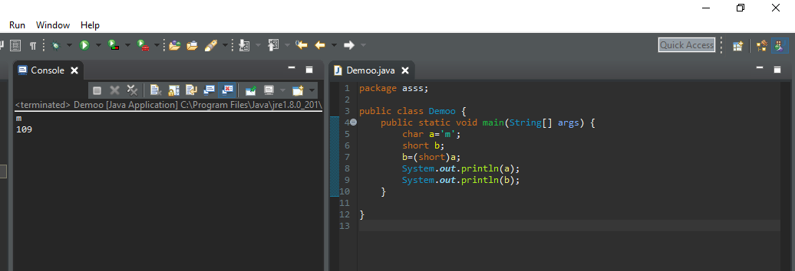

**Conclusion:** it is not possible implicit type casting of converting char data type to short data type of data, we want to use this we can modify that as per syntax. So finally it is a explicit typecasting.

**Example 4**: checking Type casting of char data type with int data type of data 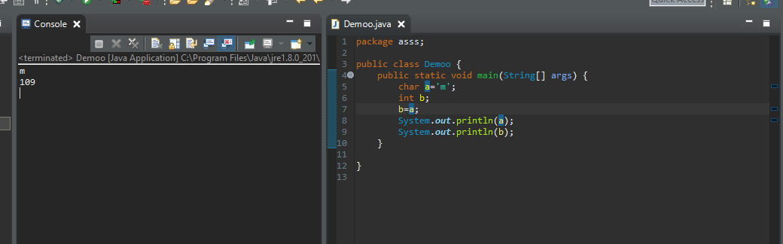

**Conclusion:** it is a implicit type casting, it is possible to implicitly converting of char data type to int data type of data.

**Example 5**: checking Type casting of char data type with long data type of data

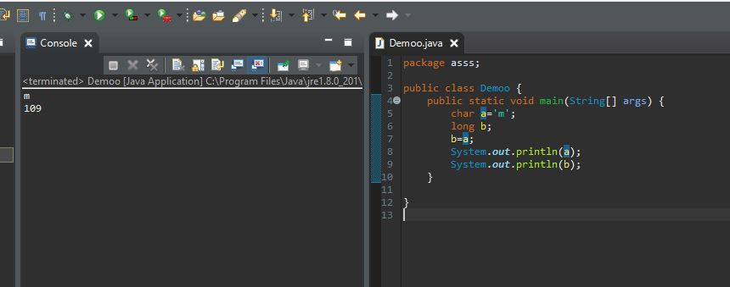

**Conclusion**: it is possible for converting of char data type with long data type of data. so it is implicit type casting.

**Example** 6: checking Type casting of char data type with float data type of data

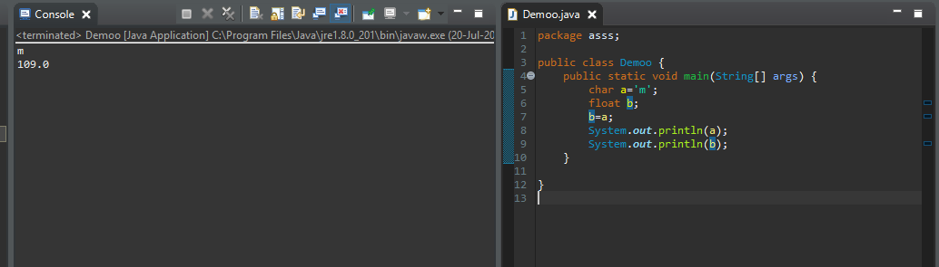

**Conclusion**: it is possible for converting of char data type with float data type of data. so it is implicit type casting.

**Example** 7: checking Type casting of char data type with double data type of data

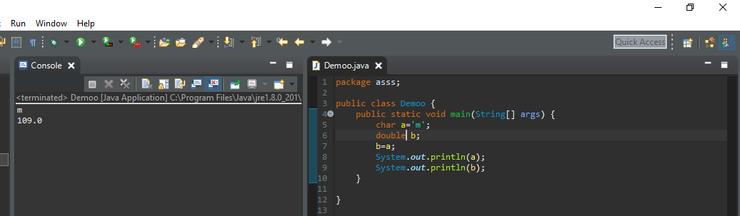

**Conclusion**: it is possible to converting of char data type with double data type of data. so it is implicit type casting.

**Example** 8: checking Type casting of char data type with Boolean data type of data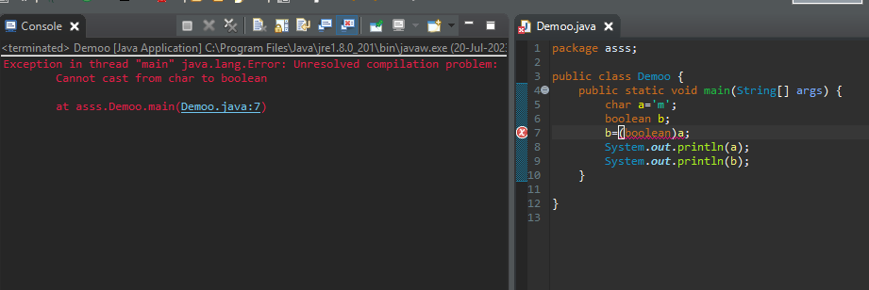

**Conclusion**: compiler will not support for casting of char data type to Boolean data type of data

‘‘Above all examples are type casting of char data type with all primitive data types of data. Now we are going to convert byte data type to all primitive data types of data.’’

1. **BYTE:**

Byte is used for integer type of data type in real world. It can be stored 1 byte of data. Let’s see all the examples of converting byte to all primitive data types of data. Range of byte is -128 to +127, in between these numbers can store byte.

**Example 1:** converting byte to char data type of data. In these conversion we know which type of type casting.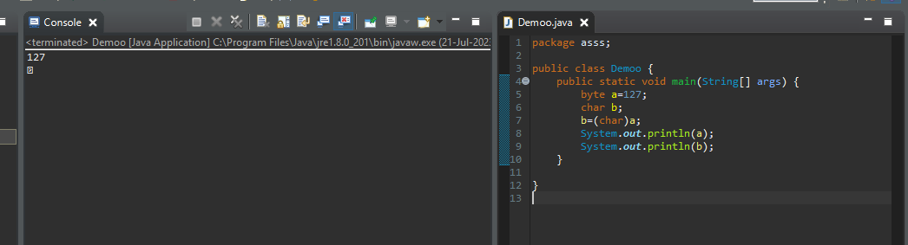

**Conclusion:** it is not possible for implicit type casting of converting byte data type to char data type of data, we want to use this we can modify that as per syntax. So finally it is a explicit typecasting.

**Example 2:** converting byte to short data type of data. In these conversion we know which type of type casting is this.

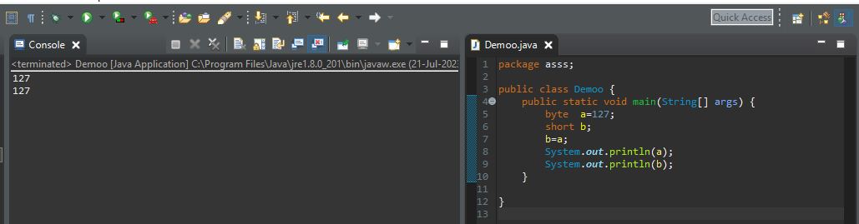

**Conclusion:** conversion of byte to short data type of data is implicit type casting.

**Example 3:** converting byte to int data type of data. In these conversion we know which type of type casting is this.

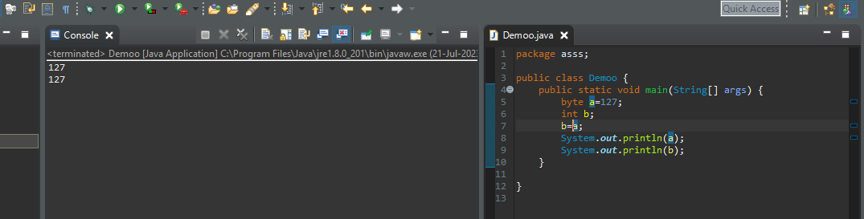

**Conclusion:** conversion of byte to int data type of data is implicit type casting.

**Example 4:** converting byte to long data type of data. In these conversion we know which type of type casting is this

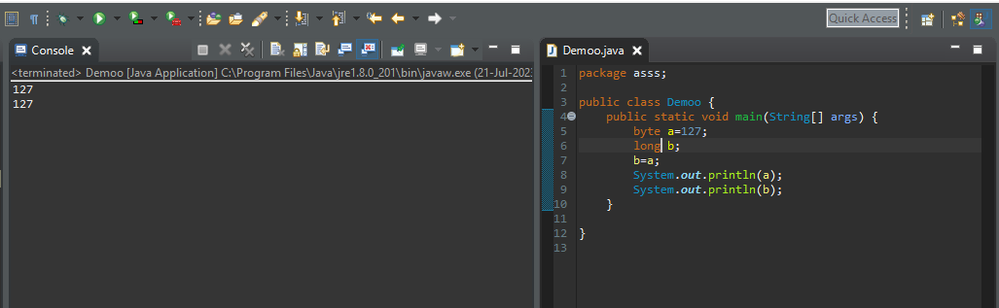

**Conclusion:** conversion of byte to long data type of data is implicit type casting.

**Example 5:** converting byte to float data type of data. In these conversion we know which type of type casting is this

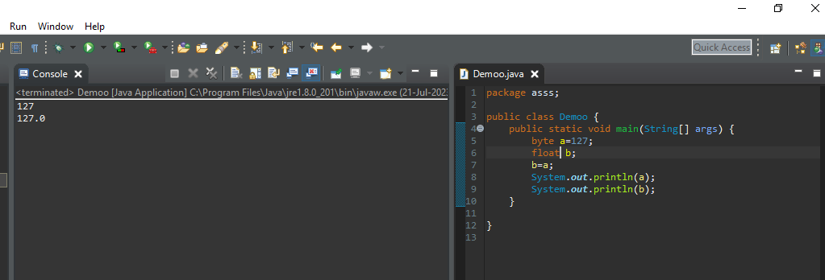

**Conclusion:** conversion of byte to float data type of data is implicit type casting.

**Example 6:** converting byte to double data type of data. In these conversion we know which type of type casting is this

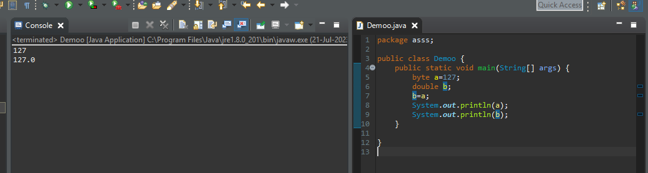

**Conclusion:** conversion of byte to double data type of data is implicit type casting.

**Example 7:** converting byte to Boolean data type of data. In these conversion we know which type of type casting is this

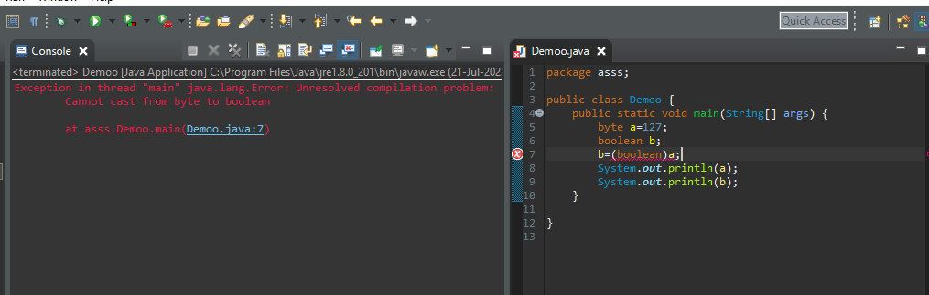

**Conclusion:** conversion of byte to Boolean data type of data casting is not possible.

1. **SHORT**: converting short data type to all primitive data types of data.

Range of short is in between -32768 to +32767 (2 bytes).

**Example 1:** converting short data type to char data type of data. In these conversion we know which type of type casting is this.

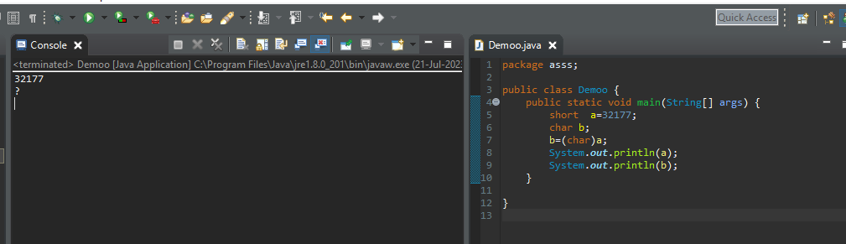

**Conclusion:** conversion of short data type to char data type of data is Explicit type casting.

**Example 2:** converting short data type to byte data type of data. In these conversion we know which type of type casting is this.

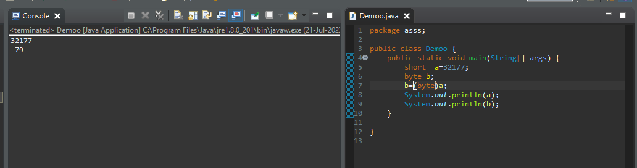

**Conclusion:** conversion of short data type to byte data type of data is Explicit type casting.

**Example 3:** converting short data type to int data type of data. In these conversion we know which type of type casting is this.

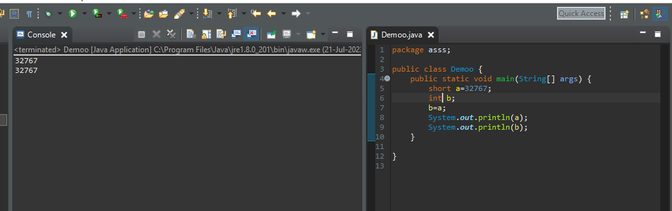

**Conclusion:** conversion of short data type to int data type of data is implicit type casting.

**Example 4:** converting short data type to long data type of data. In these conversion we know which type of type casting is this.

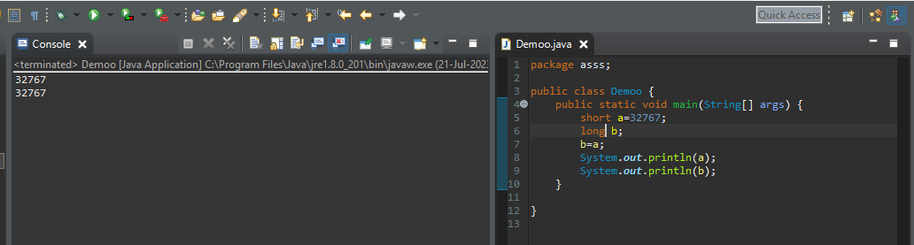

**Conclusion:** conversion of short data type to long data type of data is implicit type casting.

**Example 5:** converting short data type to float data type of data. In these conversion we know which type of type casting is this.

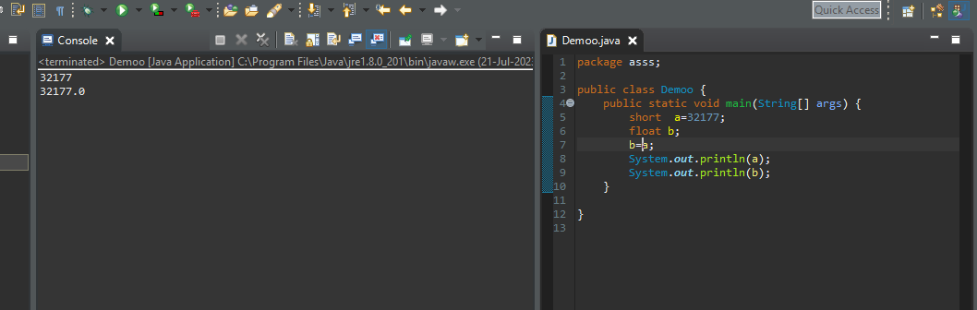

**Conclusion:** conversion of short data type to float data type of data is implicit type casting.

**Example 6:** converting short data type to double data type of data. In these conversion we know which type of type casting is this.

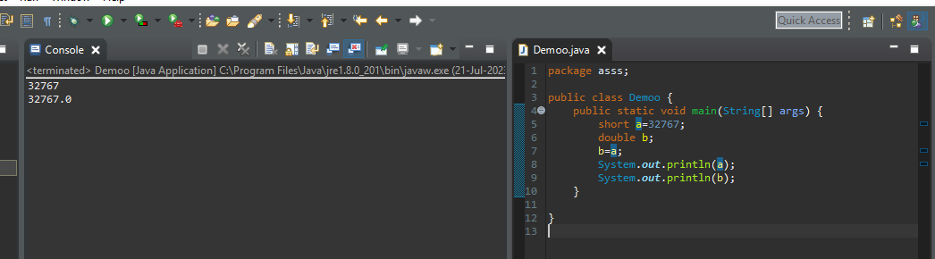

**Conclusion:** conversion of short data type to double data type of data is implicit type casting.

**Example 7:** converting short data type to Boolean data type of data. In these conversion we know which type of type casting is this.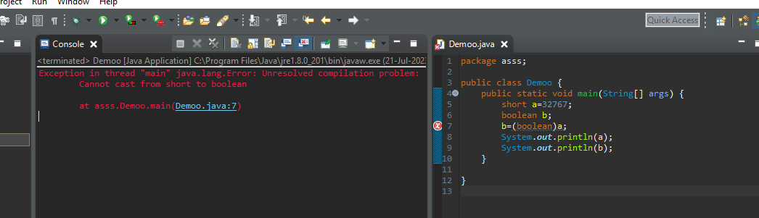**Conclusion:** conversion of short data type to Boolean data type of data casting is not possible.

1. **int:** intis used for integer type of data ,it can be stored 4 bytes of data, in between range of -2147483648 to +2147483647.

**Example 1:** converting int data type to char data type of data. In these conversion we know which type of type casting is this.

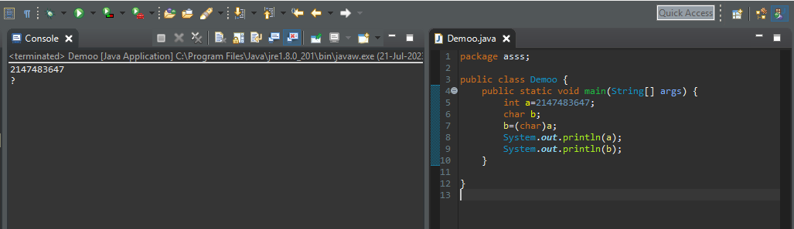

**Conclusion:** conversion of int to char data type of data is Explicit type casting.

**Example 2:** converting int data type to byte data type of data. In these conversion we know which type of type casting is this

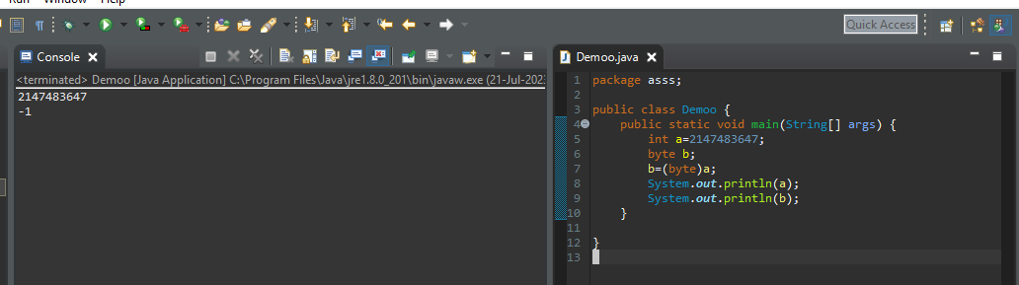

**Conclusion:** conversion of int to byte data type of data is Explicit type casting. In this conversion data loss is possible because 4 bytes of data can be converted to 1 byte of data.

**Example 3:** converting int data type to short data type of data. In these conversion we know which type of type casting is this.

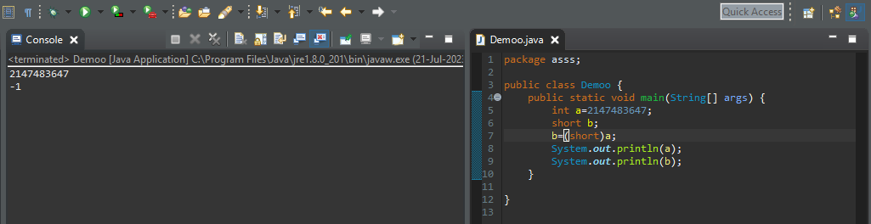

**Conclusion:** conversion of int to short data type of data is Explicit type casting. In this conversion data loss is possible because 4 bytes of data can be converted to 2 bytes of data.

**Example 4:** converting int data type to long data type of data. In these conversion we know which type of type casting is this.

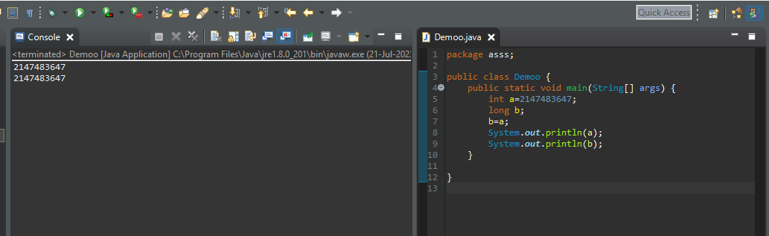

**Conclusion:** conversion of int to long data type of data is implicit type casting.

**Example 5:** converting int data type to float data type of data. In these conversion we know which type of type casting is this

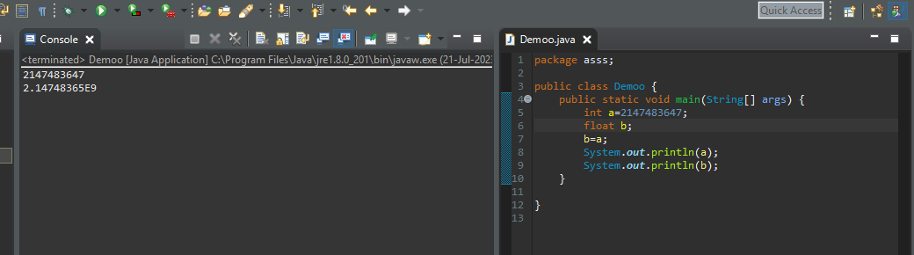

**Conclusion:** conversion of int to float data type of data is implicit type casting.

**Example 6:** converting int data type to double data type of data. In these conversion we know which type of type casting is this

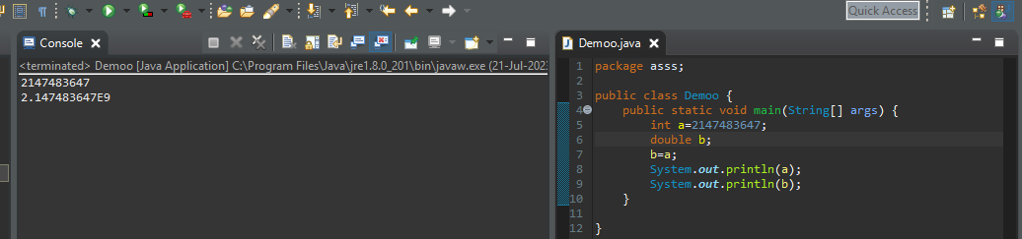

**Conclusion:** conversion of int to double data type of data is implicit type casting.

**Example 7:** converting int data type to Boolean data type of data. In these conversion we know which type of type casting is this

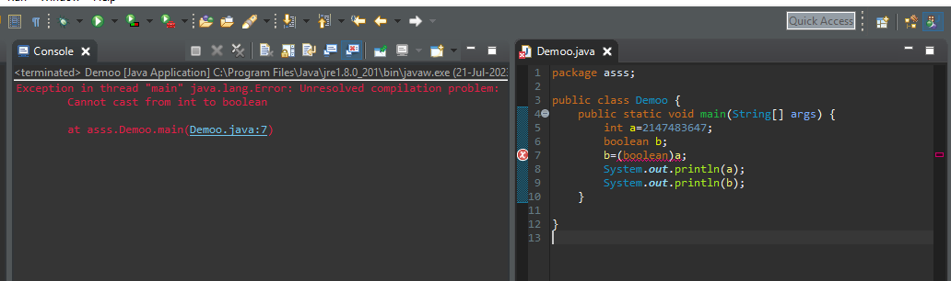

**Conclusion:** conversion of int data type to Boolean data type of data casting is not possible.

**5. Long :** it is also a integer type data type if the range of this is

-9223372036854775808l to 9223372036854775807l.

**Example 1:** converting long data type to char data type of data. In these conversion we know which type of type casting is this

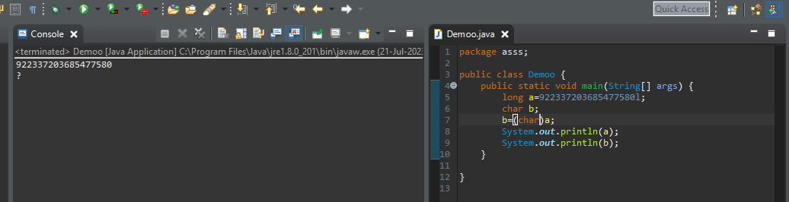

**Conclusion:** conversion of long data type to char data type of data is Explicit type casting.

**Example 2:** converting long data type to byte data type of data. In these conversion we know which type of type casting is this

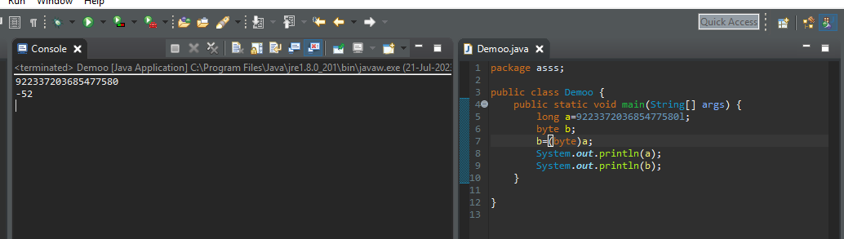

**Conclusion:** conversion of long to byte data type of data is Explicit type casting. In this conversion data loss is possible because 8 bytes of data can be converted to 1 byte of data.

**Example 3:** converting long data type to short data type of data. In these conversion we know which type of type casting is this

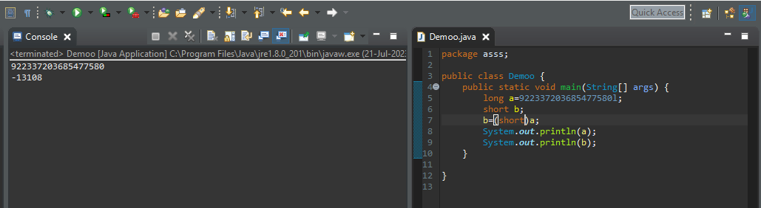

**Conclusion:** conversion of long to short data type of data is Explicit type casting. In this conversion data loss is possible because 8 bytes of data can be converted to 2 bytes of data.

**Example 4:** converting long data type to int data type of data. In these conversion we know which type of type casting is this

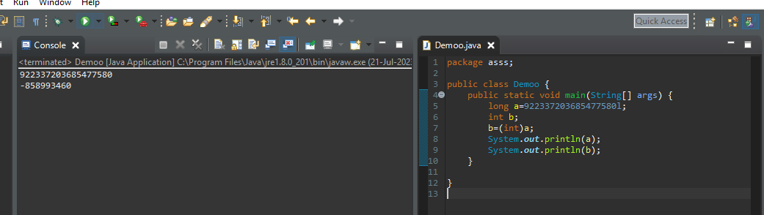

**Conclusion:** conversion of long to int data type of data is Explicit type casting. In this conversion data loss is possible because 8 bytes of data can be converted to 4 byte’s of data.

**Example 5:** converting long data type to float data type of data. In these conversion we know which type of type casting is this

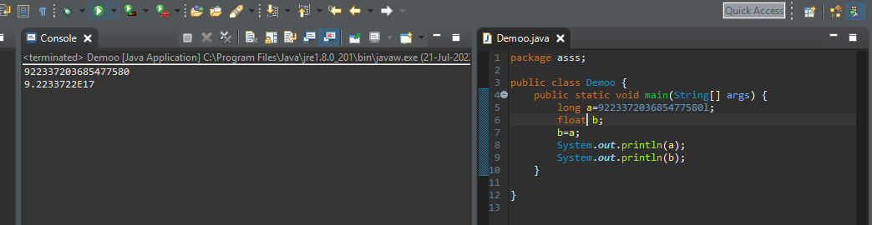

**Conclusion:** conversion of long data type to float data type of data is implicit type casting.

**Example 6:** converting long data type to double data type of data. In these conversion we know which type of type casting is this

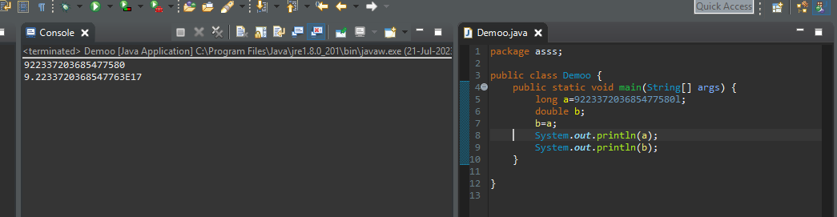

**Conclusion:** conversion of long data type to double data type of data is implicit type casting.

**Example 7:** converting long data type to Boolean data type of data. In these conversion we know which type of type casting is this

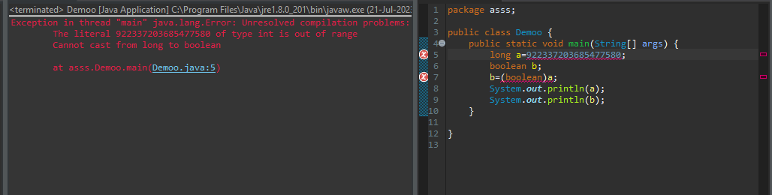

**Conclusion:** conversion of long data type to Boolean data type of data casting is not possible.

**6. Float** : float data type is a type of real number, it can be stored after decimal point only 7 digits. It is occupies 4 bytes of data.

**Example 1:** converting float data type to char data type of data. In these conversion we know which type of type casting is this

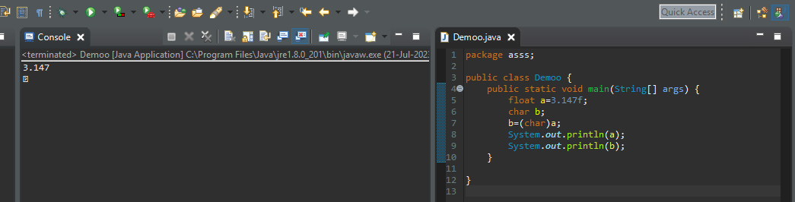

**Conclusion:** conversion of float data type to char data type of data is Explicit type casting

**Example 2:** converting float data type to byte data type of data. In these conversion we know which type of type casting is this

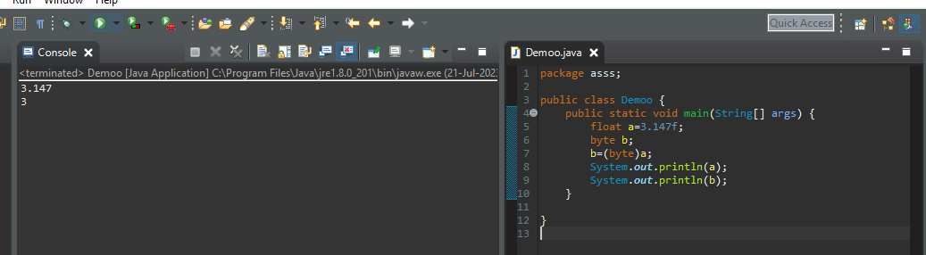

**Conclusion:** conversion of float data type to byte data type of data is Explicit type casting

**Example 3:** converting float data type to short data type of data. In these conversion we know which type of type casting is this

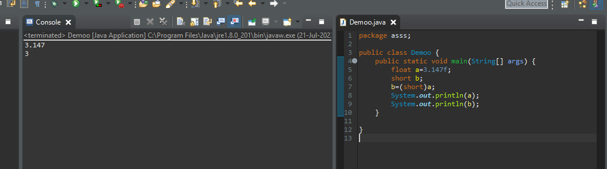

**Conclusion:** conversion of float data type to short data type of data is Explicit type casting

**Example 4:** converting float data type to int data type of data. In these conversion we know which type of type casting is this

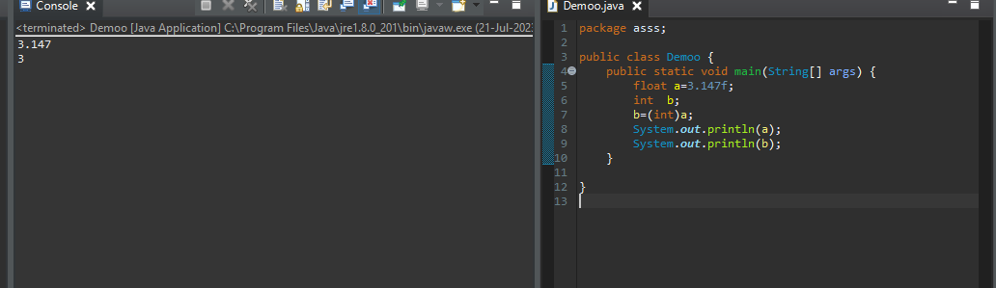

**Conclusion:** conversion of float data type to int data type of data is Explicit type casting

**Example 5:** converting float data type to long data type of data. In these conversion we know which type of type casting is this

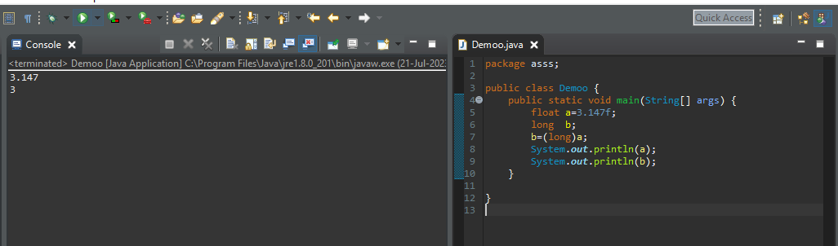

**Conclusion:** conversion of float data type to long data type of data is Explicit type casting

**Example 6:** converting float data type to double data type of data. In these conversion we know which type of type casting is this

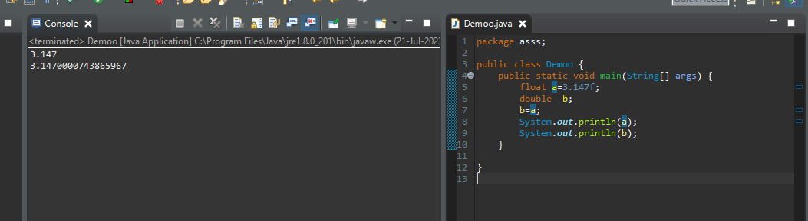

**Conclusion:** conversion of float data type to double data type of data is implicit type casting

**Example 7:** converting float data type to Boolean data type of data. In these conversion we know which type of type casting is this

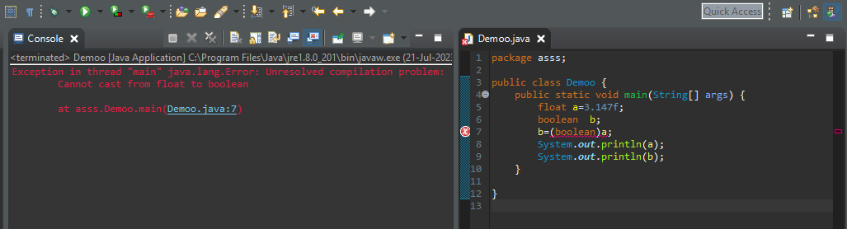

**Conclusion:** conversion of float data type to Boolean data type of data casting is not possible.

**7. Double :** double is also a real number data type ,it is stored 8 bytes of data and 15 digits after decimal point.

**Example 1:** converting double data type to char data type of data. In these conversion we know which type of type casting is this

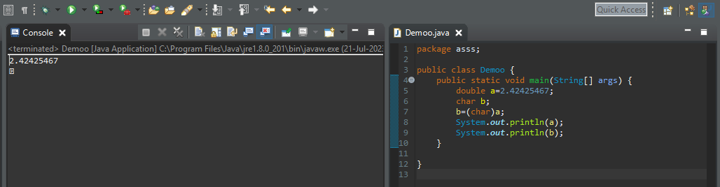

**Conclusion:** conversion of double data type to char data type of data is Explicit type casting

**Example 2:** converting double data type to byte data type of data. In these conversion we know which type of type casting is this

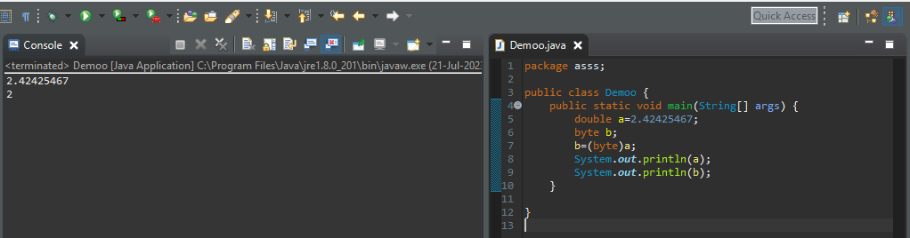

**Conclusion:** conversion of double data type to bytedata type of data is Explicit type casting

**Example 3:** converting double data type to short data type of data. In these conversion we know which type of type casting is this

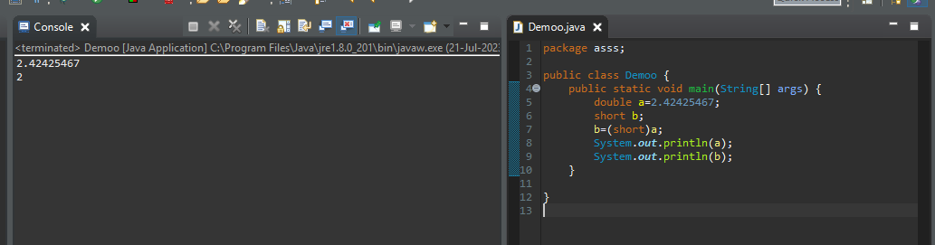

**Conclusion:** conversion of double data type to shoet data type of data is Explicit type casting

**Example 4:** converting double data type to int data type of data. In these conversion we know which type of type casting is this

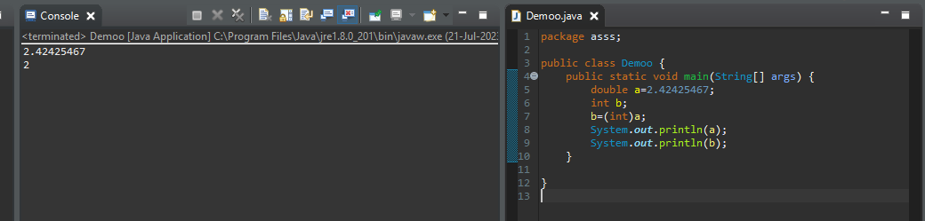

**Conclusion:** conversion of double data type to int data type of data is Explicit type casting

**Example 5:** converting double data type to long data type of data. In these conversion we know which type of type casting is this

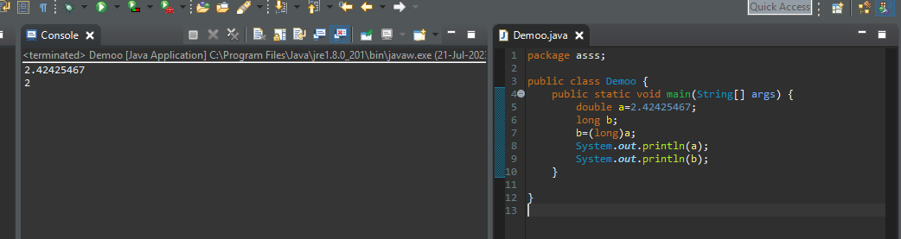

**Conclusion:** conversion of double data type to long data type of data is Explicit type casting

**Example 6:** converting double data type to float data type of data. In these conversion we know which type of type casting is this

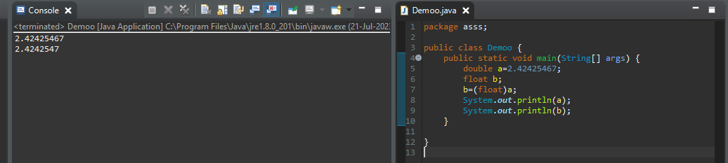

**Conclusion:** conversion of double data type to float data type of data is Explicit type casting.

**Example7:** convertig double data type to Boolean data type of data. In these conversion we know which type of type casting is this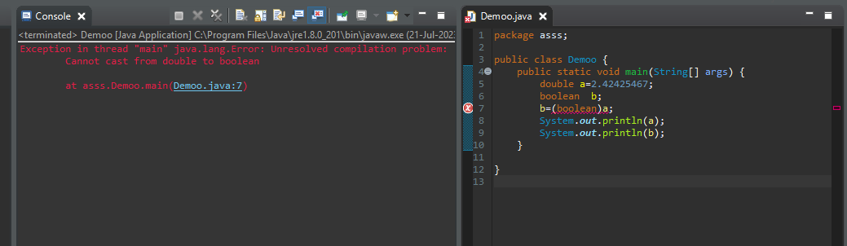

**Conclusion:** conversion of double data type to Boolean data type of data casting is not possible

**8. Boolean:** Boolean is true/ false type of data type, this is no standard size of memory allocated, depends on os, it’s either 1 byte nor 2 bytes of memory allocated

True & false are the key words.

**Example1:** Converting Boolean data type to char data type of data. In these conversion we know which type of type casting is this

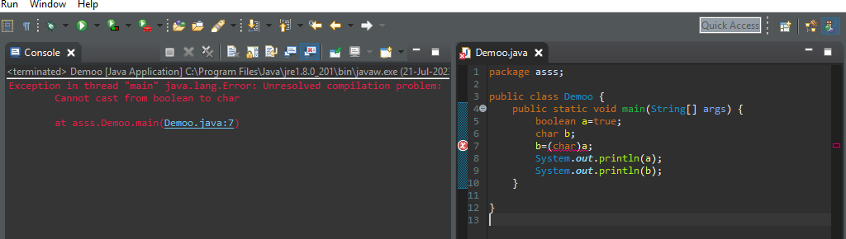

**Conclusion:** conversion of Boolean data type to char data type of data casting is not possible

**Example2:** Converting Boolean data type to byte data type of data. In these conversion we know which type of type casting is this

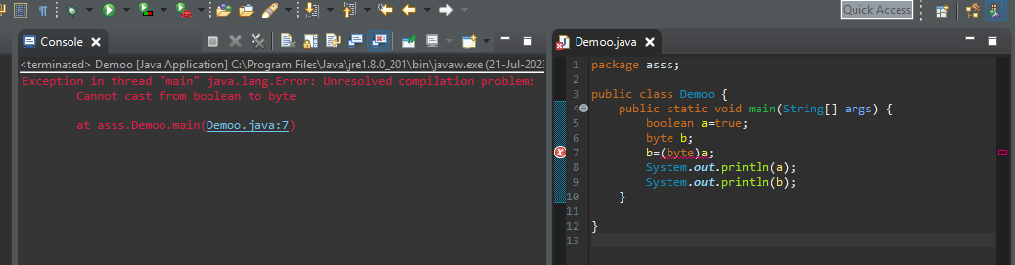

**Conclusion:** conversion of Boolean data type to byte data type of data casting is not possible

**Example 3:** Converting Boolean data type to short data type of data. In these conversion we know which type of type casting is this

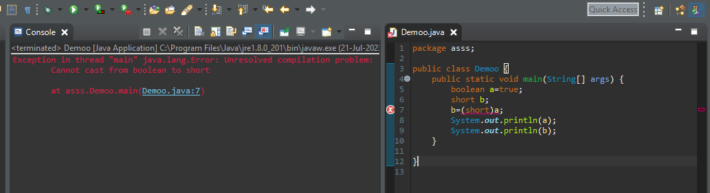

**Conclusion:** conversion of Boolean data type to short data type of data casting is not possible

**Example 4:** Converting Boolean data type to int data type of data. In these conversion we know which type of type casting is this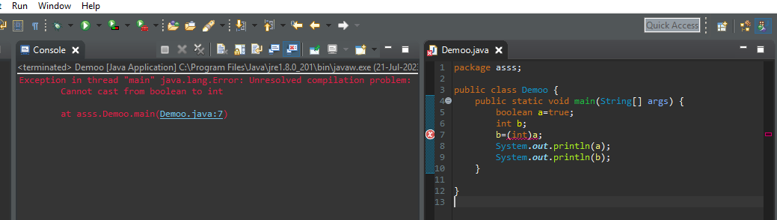

**Conclusion:** conversion of Boolean data type to int data type of data casting is not possible

**Example 5:** Converting Boolean data type to long data type of data. In these conversion we know which type of type casting is this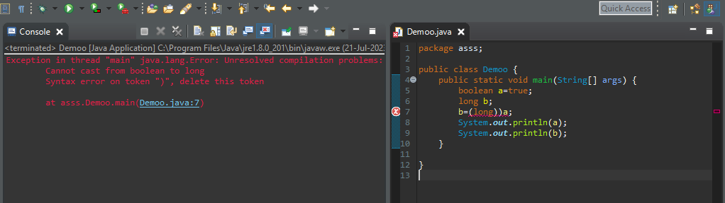

**Conclusion:** conversion of Boolean data type to long data type of data casting is not possible

**Example 6:** Converting Boolean data type to float data type of data. In these conversion we know which type of type casting is this

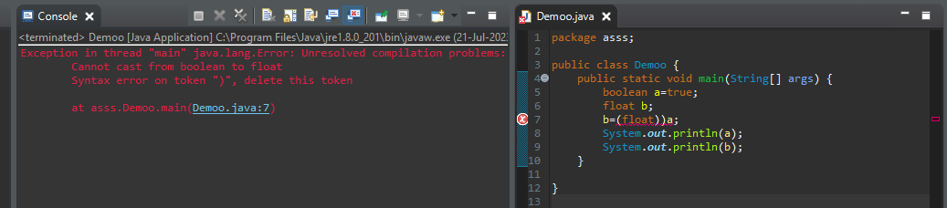

**Conclusion:** conversion of Boolean data type to float data type of data casting is not possible

**Example 7:** Converting Boolean data type to double data type of data. In these conversion we know which type of type casting is this

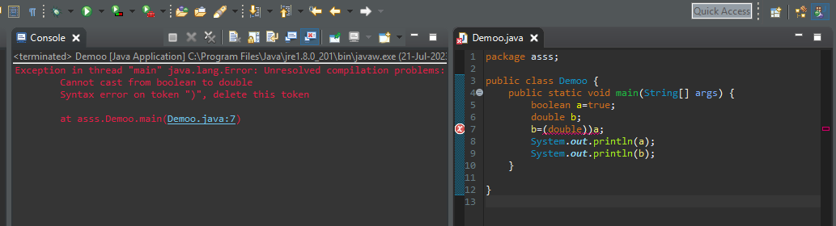

**Conclusion:** conversion of Boolean data type to double data type of data casting is not possible

This table explains type casting of each data type of data…

|  |  |  |  |  |  |  |  |  |
| --- | --- | --- | --- | --- | --- | --- | --- | --- |
|  | **char** | **byte** | **short** | **int** | **long** | **float** | **double** | **boolean** |
| **char** | NCR | EC | EC | IC | IC | IC | IC | Cann’t cast |
| **byte** | EC | NCR | IC | IC | IC | IC | IC | Cann’t cast |
| **short** | EC | EC | NCR | IC | IC | IC | IC | Cann’t cast |
| **int** | EC | EC | EC | NCR | IC | IC | IC | Cann’t cast |
| **long** | EC | EC | EC | EC | NCR | EC | EC | Cann’t cast |
| **float** | EC | EC | EC | EC | EC | NCR | EC | Cann’t cast |
| **double** | EC | EC | EC | EC | EC | EC | NCR | Cann’t cast |
| **boolean** |  |  |  |  |  |  |  | Cann’t cast |

Type casting is not possible

Type casting is possible